**Project:- Campus Placement Guide**

**Group member:- ARYA DUBEY, ANANYA RAI**

**Lab experiment 1**

**Objective:- :- Develop requirements specification for a given problem**

**Category :- web application**

**Purpose :- The purpose of this document is to build an online guide for students who want to prepare for Campus Placement, and pursuing various courses. Here you can get ever-thing in single website,**

**->Info like , which company visits your collage ,**

**->what is the package of particular company,**

**->what job role you can get as a fresher,**

**->what are the requirement for that company,**

**->what is the placement process for selection ,**

**->how many round are being conducted for placement,**

**->plus whole study material for particular round,**

**->you can also purchase books , related books in respective to particular rounds are given,**

**->hand written notes are also there,**

**->Daily quizzes are also provided.**

**Scope :- The purpose of this Campus Placement Guide**

**Is to ease preparation for Campus Placement and to create a convenient and easy-to-use guide for students preparing for various Campus.** Above all, we hope to provide a comfortable user experience along with the best information available.

**Introduction:- The system made before were also providing quite use full information , but those where providing pieces of information, but not a complete guide with systematic interface.**

**So our proposed system is providing complete guide, while using thing you will not need to navigate through various websites , for other information. And this could you very useful for 1st year students as they don’t have much idea about anything.**

**Advantages:- Easy to use,**

* **User friendly interface,**
* **Complete guide, beginners and first year student can also understand the process of Campus Placement very easily.**
* **Books related to respective selection rounds are given so you don’t need to navigate on other website to think which book I should buy.**
* **Whole Information about particular company is given, with whole placement process systematically.**
* **Latest information about internships and competitions for selection is also given.**

**Functional requirement:-**

* **Page 1 :- User should be able to find their respective Course, like B.tech, M.tech, MBA and many more.**
* **Page 2 :- User should be redirected to next page , in which they should be able to select their preferred company. They should also get the option to know which company visits their collage, and should also get option to know about internship and competition based hiring.**
* **Page 3:- If user have selected particular company they should be redirected to next page having info about that company and mainly their** t **Recruitment Process with option of getting studying stuffs related to particular round. And info about which subject should they study.**
* **Page 4:- In this page user should get links of studying material for each round, should have option to view and download hand written notes, and should be able to buy books.**
* **Page 5:- User should be asked to login in their account for purchasing books.**
* **Page 3:- If user selected option to know about which company visits their collage on page 2 then they should be redirected to page having option to select their collage and know about which company visits their collage and with how much package.**
* **Page 3:- If the user select option to know about internship and competition based hiring, on Page 2, they should be redirected to this page with latest information about internship and competitions for selection.**

**Non functional requirement:**

* **A website should be capable enough to handle 20k users without affecting its performance**
* **It’s response time & loading time should be less**
* **Database should work properly so that users can conveniently be able to download pdfs**
* **While selling books, their quality should be check as no option to return or exchange is provided.**
* **The information provided in not official but and does not take responsibility of any wrong information, but our team will try best to provide correct information.**

**Software tools:- visual studio code , xampp control panel ,browser supporting HTML5 and CSS 3, MySQL database.**

**Deployment:- Any web browser(try to use updated), operating system ,Internet connection.**

**Hardware specification:- any device with network connected , operating system which supports to open web browser, audio, video facility camera and microphone.**

**Referred Websites:-**

* <https://www.rgpvnotes.in/>
* <https://www.geeksforgeeks.org>
* <https://www.monster.com>
* <https://www.w3schools.com>

**Lab experiment 2**

**Object:- develop DFD model**

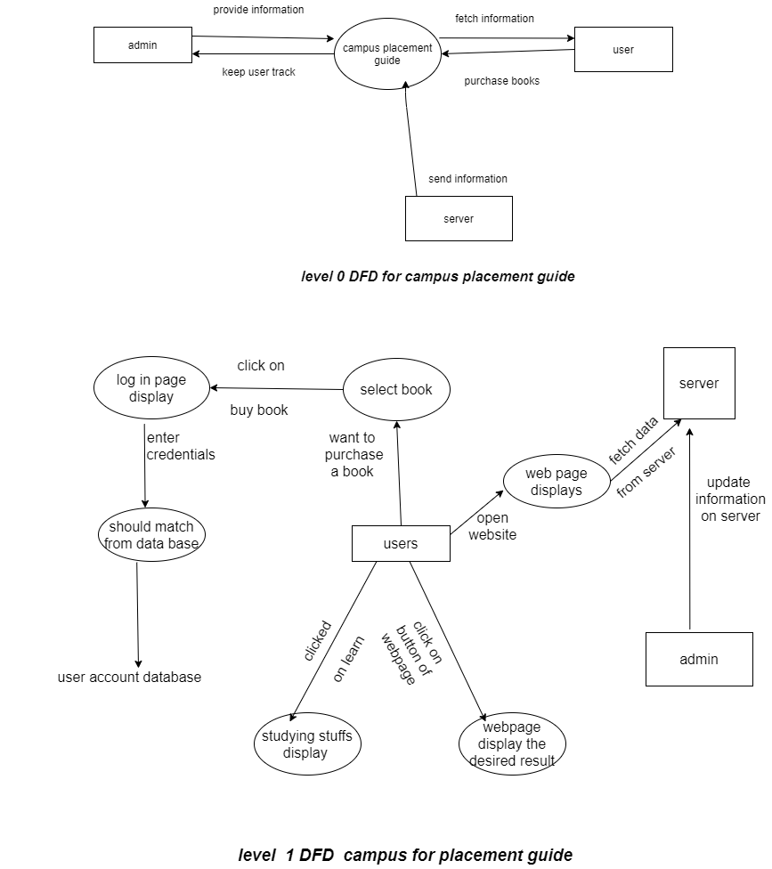

Data dictionary

|  |  |  |  |  |  |  |  |
| --- | --- | --- | --- | --- | --- | --- | --- |
| Entity name | Entity description | Column name | Column description | Data type | length | Primary key | Unique |
| user | A user in this case is usually a student who wants to prepare for campus placement | User id  password | Unique id for user  login credential | Var char  Var char | 15  10 | True  false | True  false |

**Lab Experiment 4**

**Object:-Develop an E-R diagram**

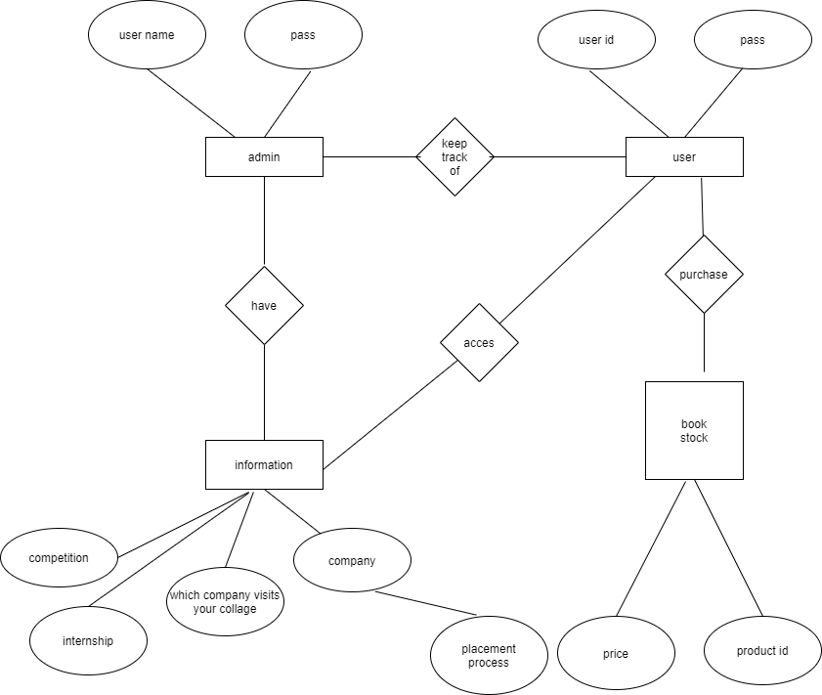

Lab experiment 5

Object:- Develop UML Use case model for a problem

